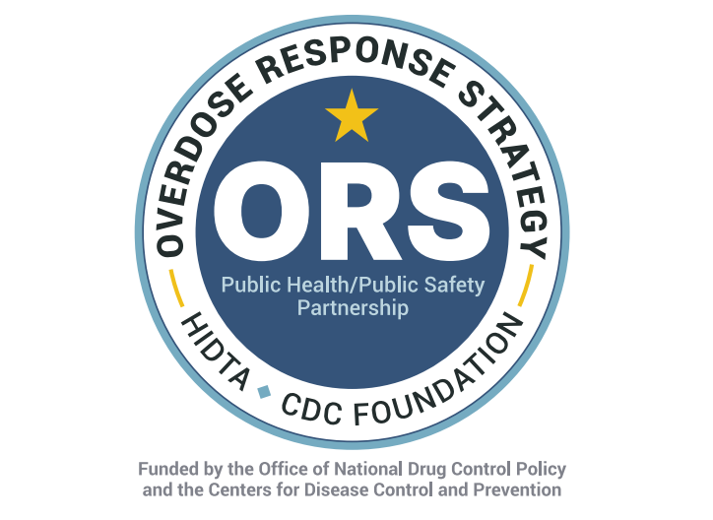

August 12, 2025
CARFENTANIL DETECTED IN ILLICIT DRUG SUPPLY
This memo provides an alert for first responders, emergency departments and the public at large. The San Diego Overdose Response Strategy (ORS) team, the San Diego District Attorney’s Office and the San Diego/Imperial Valley HIDTA (High Intensity Drug Trafficking Area) have been alerted that carfentanil has been detected in a recent seizure of counterfeit M-30 pills, without the presence of fentanyl.
Carfentanil is a fast-acting synthetic opioid, which is 100 times stronger than fentanyl. A person who has taken carfentanil may stop breathing, lose consciousness, exhibit blueish or grayish skin tone or make gurgling/rattling noises.
Higher doses of Naloxone may be necessary to reverse an overdose, multiple doses may be needed. Members of the public should call 911 immediately if an overdose is suspected.
Fentanyl test strips are not likely to detect carfentanil. A negative result on a fentanyl test strip does not mean that a pill or substance is safe. Further, hospital toxicology screens may not detect carfentanil.

