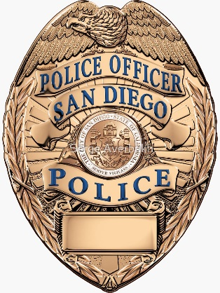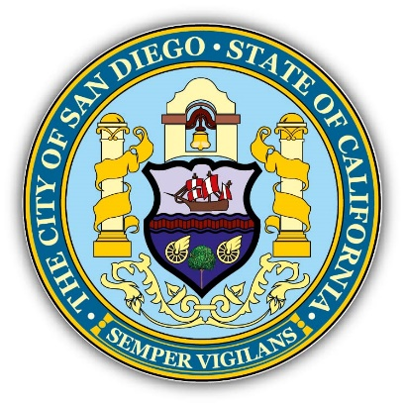
San Diego Police Department
PRESENTS:
BICYCLE PATROL INSTRUCTOR COURSE
**Attendees must have previously passed a POST Basic Bicycle Patrol Course**
August 26th – August 29th
^{0700-1600 hours}
^{Hosted at:}
San Diego Police Department
4020 Murphy Canyon Rd.
San Diego, CA. 92123
Contact: Sgt. Richard Fox RAFox@pd.sandiego.gov
Sgt. Marty Reinhold MReinhold@pd.sandiego.gov

This course is designed to teach tactics, techniques, and procedures needed to safely instruct a basic bicycle patrol course. This course is a four-day, 40 hour P.O.S.T. certified class.
Post Plan N/A
POST COURSE CONTROL #
2400-23830-25-001
Course has no cost to attend

Required Equipment:
- Police Bicycle
- Bicycle Uniform (T-shirt, Jacket, Shoes, Helmet, Gloves, Gun belt, Vest, Eyewear, etc.)
- Spare Equipment (Spare inner-tubes and appropriate tools), Water Bottle, Sunscreen
- NOTE: Attendees should be in good physical condition and prepared to ride 10-15 mile per day
- Be prepared to instruct other students as they attend a POST Basic course.

