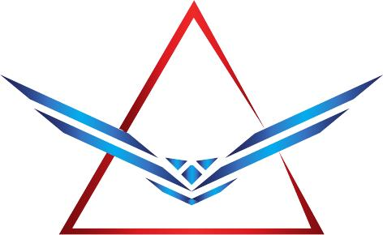 | All Security Enforcement Training  14420 Civic Dr. #5  Victorville, CA 92392  p. 760-241-1199, c. 310-406-7600

STC ADULT CORRECTIONAL OFFICER TRAINING OPPORTUNITY

COURSE: BSCC/STC ACO Adult Correctional Officer Core Course
LOCATION: Santa Ana Police Department
1091 West Civic Center Drive, Santa Ana, CA 92702
Date: July 14, 20225 to August 7, 2025

Tuition: Call ASET for Pricing

A.S.E.T. would like to offer our Board of State and Community Corrections (BSCC) Standards and Training for Corrections (STC) Certified Course for the Adult Corrections Officer Core Course (ACO) to your current or future employees. Currently this is a 19-day course (4 weeks), covering 10 hours daily of the 187 approved training hours. Our instructors are highly trained through the Department of Corrections, LAPD, Sheriff Departments, and the U.S. Military. All our instructors have been certified to teach through the BSCC STC, BSIS, POST and the NRA.

Santa Police Department will be hosting our upcoming event. Please feel free to contact us directly for pricing and availability, space is limited in this academy. Thank you for considering All Security Enforcement Training and we look forward to working with you.

Sincerely,

Andy Leuridan, CEO STC Certification Number
Rose Leuridan, Operations Manager 07470033
Office: 760-241-1199

