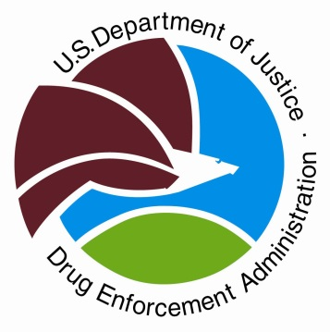
Drug Enforcement Administration
SAN DIEGO FIELD DIVISION
Brian Clark, Special Agent in Charge
www.dea.gov
Twitter: @DEASANDIEGODiv
Instagram: @deasandiegodiv

May 9, 2025
Contact: Kelly McKay, Public Affairs Specialist

NEWS RELEASE
For Immediate Release

DEA Safely Disposes 620,000 Pounds of Unused Medication on 28th National Prescription Drug Take Back Day

WASHINGTON – DEA and nearly 4,500 law enforcement agencies joined forces last month to dispose of more than 620,000 pounds of unneeded and expired medications in an effort to prevent drug misuse and abuse. The spring collection event marked DEA’s 28th National Prescription Drug Take Back Day.

The DEA San Diego Field Division collected nearly 3,368 pounds of drugs from 30 locations located in San Diego and Imperial Counties. Specifically, San Diego County collected 3,293 pounds and 75 pounds was collected in Imperial County. Local law enforcement partners with year-round drop boxes dropped off an additional 7,795pounds, bringing the total collected to 11,163 pounds.

Since its inception 16 years ago, DEA Prescription Drug Take Back Day has helped Americans safely remove nearly 19.8 million pounds of expired, unwanted, or unused medications from their homes.

“We want to thank our state, local, and tribal partners for their continued support of DEA’s National Prescription Drug Take Back Day,” said DEA Acting Administrator Robert Murphy. “For sixteen years you have continued to show up to protect your communities by helping to remove the threat of medications from falling into the wrong hands. This program would not be possible without the support of our law enforcement and community partners.”

“We appreciate all our local partners for joining us on Take Back Day to keep San Diego and Imperial Counties safe and free of unused, unwanted, and unneeded medications, said DEA San Diego Special Agent in Charge Brian Clark.

If you missed National Prescription Drug Take Back Day or want to clean your medicine cabinet out on a semi-regular basis, safe disposal options are available year-round. Nearly 17,000 pharmacies, hospitals, and other authorized collectors nationwide continue to provide secure medication drop boxes, and many police departments offer permanent collection locations. To find a year-round drop off location, visit Every Day is Take Back Day.

Complete results for DEA’s spring National Prescription Drug Take Back Day are available at Take Back Day.
# # #

