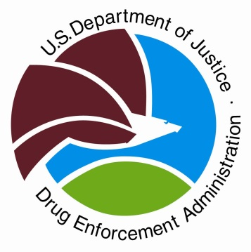
Drug Enforcement Administration
Shelly S. Howe, Special Agent in Charge
www.dea.gov
Twitter: @DEASANDIEGODiv

January 29, 2024
Contact: Kelly McKay, Public Affairs Specialist
571-324-6204
NEWS RELEASE
For Immediate Release

Year in Review: DEA Innovates to Fight Fentanyl

WASHINGTON – In 2023, the U.S. Drug Enforcement Administration marked its 50th anniversary as the only federal agency dedicated to fighting deadly drugs and drug-related violence. This milestone celebrated a half century of dedication to fighting drug trafficking in the United States and around the world, which threatens the public safety, health, and national security of our country. DEA also ushered in a transformation of DEA’s organization and strategy to meet this extraordinary moment in time as the United States confronts the deadliest drug threat our country has ever faced—fentanyl.

Today, fentanyl is the leading cause of death for Americans between the ages of 18 and 45. In calendar year 2023, DEA seized more than 77 million fentanyl pills and nearly 12,000 pounds of fentanyl powder. This is the most fentanyl seized by DEA in a single year. It amounts to more than 386 million deadly doses of fentanyl—enough to kill every American.

The DEA San Diego Field Division, which covers San Diego and Imperial Counties, seized an estimated 11.4 million fentanyl pills in calendar year 2023; 2.5 times more than was seized in 2022.

The fentanyl we see today is even deadlier than before. Fentanyl pills today are more potent. DEA laboratory testing in 2023 showed that 7 out of 10 pills tested contain a potentially deadly dose of fentanyl. This is an increase from 4 out of 10 pills in 2021 and 6 out of 10 pills in 2022. A potentially deadly dose is considered just two milligrams of fentanyl, which is approximately the amount that fits on the tip of a pencil.

The Centers for Disease Control and Prevention is predicting record numbers of drug poisonings for 2023, with their latest estimate for the 12-month period ending June 2023 at 112,323 American lives lost. Nearly 70% of these drug poisonings are from fentanyl.

DEA has responded to this unprecedented threat with unprecedented action. DEA’s mission is to save American lives by defeating the two cartels that are responsible for the vast majority of fentanyl that is flooding our country: the Sinaloa Cartel and the Jalisco Cartel. DEA has built a new strategic layer of Counter Threat Teams to focus on each cartel and the illicit finance networks that fund them both. These Counter Threat Teams draw on the intelligence from our 334 offices around the world to map the cartels’ global networks and to identify targets for investigation and prosecution. While the cartels’ operations are based in Mexico, DEA has identified more than 50 additional countries where these criminal networks operate. DEA has also traced the cartels’ global supply chain around the world. The cartels purchase chemicals from companies in China, mass produce the fentanyl in Mexico, and then traffic and distribute finished fentanyl widely throughout the United States. In 2023, DEA took actions to disrupt every step of this fentanyl supply chain—from bringing the first-ever charges against Chinese chemical companies and their owners for supplying precursor chemicals, to charging and extraditing leaders, enforcers, and associates of the cartels in Mexico, to tracking down the criminal organizations and individuals in our communities responsible for the last mile of distribution of fentanyl on our streets and on social media.

These are DEA’s latest actions in our unwavering commitment to protect the lives of Americans. DEA remains relentlessly focused on one unifying mission—saving American lives. DEA will continue to act, innovate, and follow a data-driven, intelligence-led approach, to defeat the fentanyl threat and meet the challenges of tomorrow.

# # #

