

OWENS TRAINING AND CONSULTING PRESENTS:
“Safety Awareness, Self-Defense for Teens and Parents”

There will always be crime. However, many crimes are preventable. This 2-hour course will teach you the skills and mindset to avoid becoming a victim of a crime. The instructors will also teach simple techniques that will increase your odds of escaping an attacker. This course is informative and fun.

When: Saturday February 3, 2024 9:00 AM- 11:00 AM or 1:00 PM-3:00 PM
Where: Escondido Police and Fire Headquarters, 1163 N. Centre City Parkway
Cost: Free
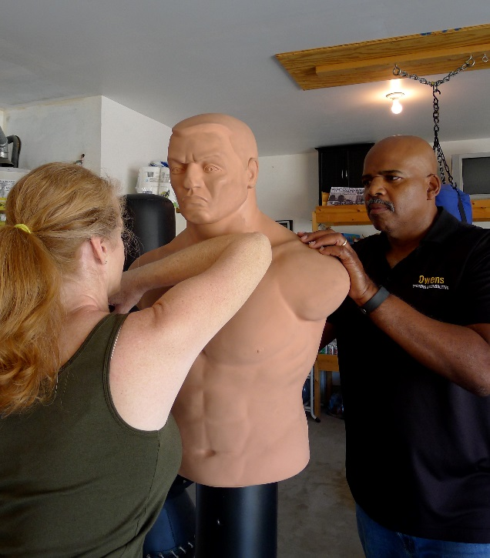
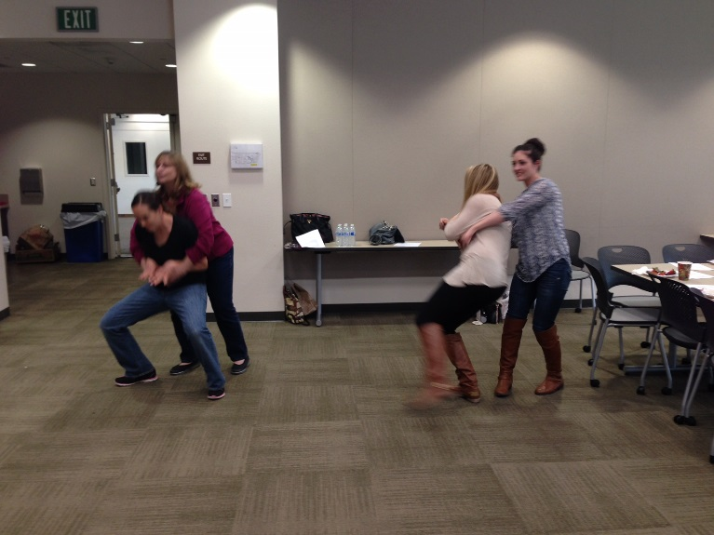
To Register: Contact Patricia Cruz Pcruz@escondido.org 760-839-4769
Lead Instructor Al Owens is a retired Police Lieutenant and USMC Veteran, who has taught self-defense for more than 25 years. For more information about Owens, see: www.owenstrainingandconsulting.com

