9665 Granite Ridge Drive, San Diego, CA

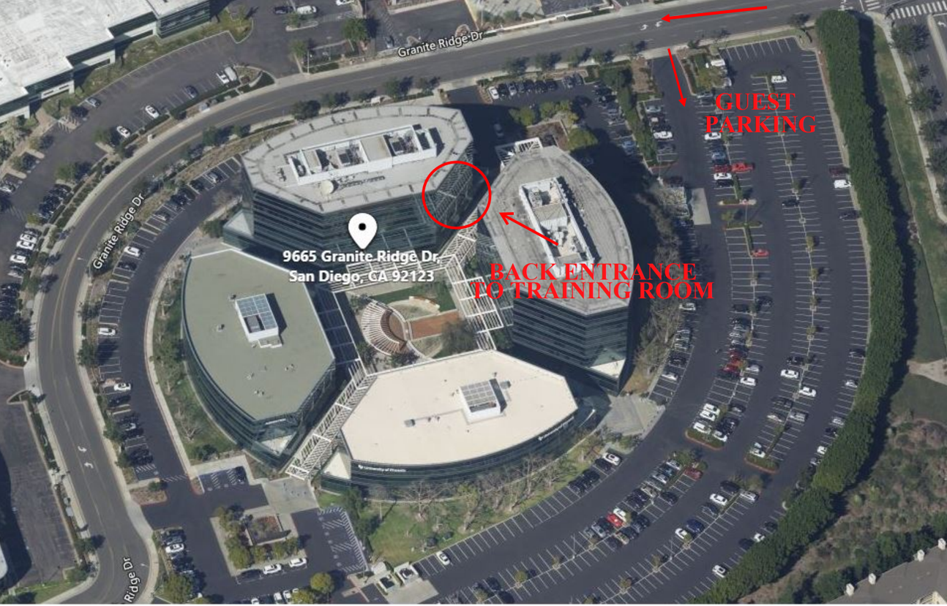

Directions from Interstate 15:
Exit Aero Drive and turn westbound
Turn left (southbound) at Daley Center Drive. (Note: A right turn northbound is Ruffin Road)
Turn right at the first light – Granite Ridge Drive
Turn immediately left into Guest Parking (see map)
Training Door is on side of building (see map). There will be signs pointing to the room.

