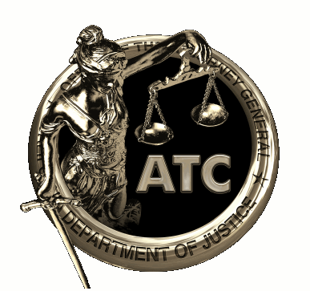

ELECTRONIC SURVEILLANCE (WIRETAP)

STATE CERTIFICATION COURSE

(POST# 9260-22020-20034)
Thursday, November 4, 2021 (0800-1700 hours)

The California Department of Justice, Advanced Training Center, will present this course at the Law Enforcement Coordination Center (LECC) in San Diego.

Course Description: This 8-hour course is for peace officers, federal law enforcement officers and qualified individuals assigned to intercept and record wire communications ("wiretaps"). This class covers the legal basis for California wiretap operations as well as the practical and tactical aspects of operating and monitoring a wiretap. Penal Code Section 629.94 requires successful completion of this course before seeking authorization for, or participating in, wiretap operations.

Who Should Attend: Qualified individuals assigned to investigate narcotics, murder, solicitation to commit murder, gangs, bombing of public or private property, aggravated kidnapping, or conspiracy to commit any of those crimes, and who will be involved in a court-authorized state wiretap and those requiring 5-year State re-certification.
Course Objectives: Upon completion of this course and a written examination, students are certified by the Office of the Attorney General of the State of California to participate in wire intercept operations.
Instructor: Dale Kitching, Supervising Deputy District Attorney, has over 27 years of experience with the Sacramento County District Attorney’s Office, 18 years in the Major Narcotics Unit and 20 years as a Special Assistant U.S. Attorney. Mr. Kitching is recognized throughout California for his expertise in electronic surveillance procedures and has provided instruction to thousands of law enforcement personnel on this subject.
Pre-Registration is Required: Seating is limited. Please register online at https://atc.guiweb.com. If you need additional information, please contact Tricia Nelson, Program Manager at (916) 695-1814 or tricia.nelson@doj.ca.gov.

Additional Information: This is a POST Plan IV reimbursable course and is a free course for Officers/Agents from POST reimbursable agencies only. For State and Federal Law Enforcement Officers/Agents and civilian linguists, there is a tuition charge of $69.00, payable at the door. Payment must be made by check or money order to POST.

