Police Recruit Workshop for Potential Applicants

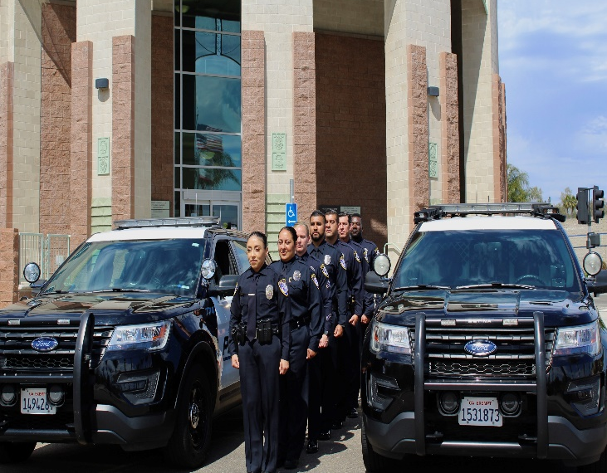
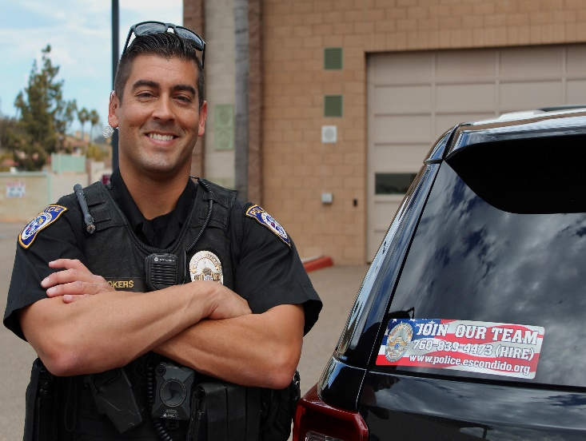
LOCATION:
Escondido Police and Fire Headquarters
1163 N Centre City Pkwy
Escondido, CA 92026

Community Room
C o u r s e
I n f o r m a t i o n
Topics include:

- Application Process
- Test Preparation
- Oral Interviews
- Background Investigation
- Q & A

Who Should Attend?
DATE & TIME:

Saturday, July 17th, 2021

9:00 A.M. to 12:00 P.M.
or
1:00 P.M. to 4:00 P.M.

The workshop is designed for individuals who are interested in
pursuing a law enforcement career. Attendees will learn what it takes to become a police officer and how to better prepare for the testing, selection process, and police academy program.

This course is free of charge. Attendees must be 18 years or older.
Register Soon – Class Size is Limited!

FOR RESERVATIONS CONTACT:
EPD Training Division:
(760) 839-4769 or email
pcruz@escondido.org
Please bring pen, paper and flash drive. Instructor will download information on the flash drive.

Instructor: Retired Escondido Police LT. Al Owens has sat on numerous hiring and promotion panels and was a Police Academy Instructor for 13 years.

*Current Health Regulations adhered to.

