El Cajon Police Department
Is hosting a 24-hour Standardized Field Sobriety Testing Course
March 30, 31 and April 1, 2020
-Will include an Alcohol Correlation Study-
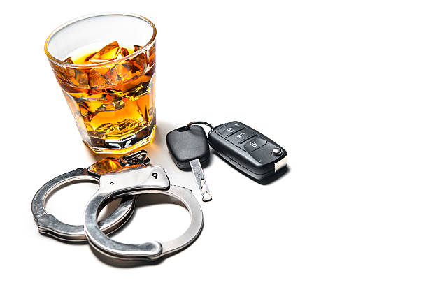

El Cajon Police Department Community Room
100 Civic Center Way, El Cajon CA
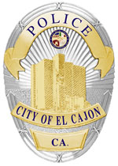

Contact:
Amber Haflich ahaflich@cityofelcajon.us with students name and POST ID or Officer Ken Harris at kharris@cityofelcajon.us or 619-579-4237 with questions.
*Class is limited to 24 students 20 seats available as of 3/9/20*

