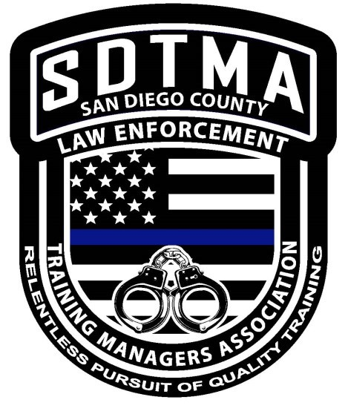SDTMA
San Diego Training Managers’ Association www.sdtma.org

The San Diego Training Managers’ Association encourages cooperation between law enforcement agencies and associations who are dedicated to professional law enforcement training. The goal is to improve professional police training through the exchange of training materials, ideas, knowledge, and techniques and to collect, collate, coordinate, and distribute data, information, ideas, knowledge, methods & techniques, by any suitable means, with the intent to promote efficient, effective, quality training.

2019 Annual Training Manager Luncheon Meeting
Filippi’s Pizza Grotto (in the private room) 5353 Kearny Villa Rd., San Diego, CA 92123

Thursday 11/21/19
11:00 AM—12:30 PM

Please join us and we’ll buy you lunch! Feel free to invite other San Diego County Law Enforcement Training Managers you may know. Make sure to bring plenty of business cards for networking. Come and go as you please! We will conduct a little business and then get to know each other better in a more casual, relaxed setting over some delicious pizza.

