
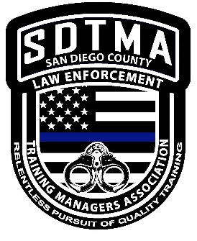

Topics Covered at the Seminar:

- 10 Families at Risk

- 5 Concurrent Themes for Success

- Background Investigations

- Ethical Decision Making

- Customer Service-Creating Some WOW

- Top 10 Things that get Cops in Trouble

This training seminar will provide all employees who work in law enforcement an expanded level of knowledge and the ability to apply it to your specific field

San Diego Training Managers
Association Proudly Presents:

One Day Training Seminar- Featuring Gordon Graham

“What Real Risk Management is All About”

Thursday, October 17, 2019
Internationally recognized 33-year veteran (retired) of California law enforcement, and a practicing attorney with a background and formal education as a risk manager Mr. Graham combines his knowledge in multiple areas with the goal of educating the attendee on how to better protect themselves, their employer, their profession and their family.

Location:

Rock Church of San Marcos

1370 W. San Marcos Blvd.

San Marcos, CA 92078

8:00 AM – 5:00 PM

Check in begins at 7:00 AM

(Coffee and Pastries will be provided)

Enrollment fee $20 a person

To register: email SDTMA Treasurer Patricia Cruz at pcruz@escondido.org

or call 760-839-4769

Cash or Check at the door is accepted with enrollment

Checks can also be mailed ahead

Checks can be made out to SDTMA

Attention: Patricia Cruz, SDTMA Treasurer

Escondido Police Department

1163 N. Centre City Parkway

Escondido, CA 92026

Open to all Law Enforcement personnel, including sworn, civilian staff and volunteers

ID Required at Check-In

