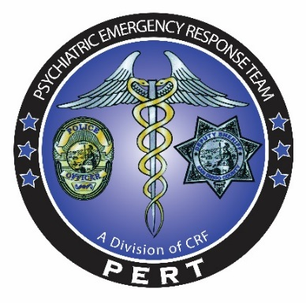

PERT CRT
Crisis Response Training
Fully interactive training encompassing mental health crisis
De-escalation and law enforcement responses
0700-1700 Hrs.
Open to all Law Enforcement Agencies

Presented by:
Mark Marvin, Ph.D., Director PERT
Marla Kingkade, Law Enforcement Liaison PERT

Training is designed for Law Enforcement

PERT Training Dates

Wednesday July 25, 2018 | La Mesa PD | 5940-20763-18-001 | Class size 30 students
Thursday October 25, 2018 | Chula Vista PD | 5940-20763-18-002 | Class size 30 students
Wednesday November 14,2018 | La Mesa PD | 5940-20763-18-003 | Class size 30 students
Wednesday April 24, 2019 | Carlsbad PD | 5940-20763-18-005 | Class size 30 students

Registration:
*Please email the PERT training coordinator at Christina.Martinez@comresearch.org. *Please submit the following: Name, title/rank, dept. /division, POST ID number, email and a phone number. Spots fill quickly, please register early to guarantee your spot.

For the simulator and scenarios bring your empty duty belt.

STC Cert No. 0017-083597

