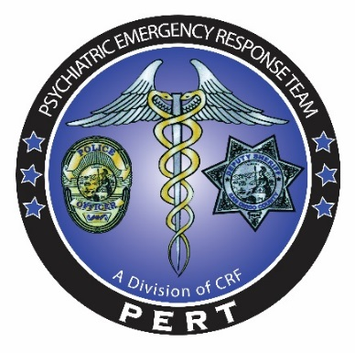

PERT
Intro to Mental Health
Fully interactive training encompassing mental health crisis
De-escalation and law enforcement responses
0700-1700 Hrs.
Open to all Law Enforcement Agencies

Presented by:
Mark Marvin, Ph.D., Director PERT
Marla Kingkade, Law Enforcement Liaison PERT

Training is designed for Law Enforcement

PERT Training Dates

Tuesday August 21, 2018 | 2400-20906-18-001 | Class size 50 students
Tuesday March 19, 2019 | 2400-20906-18-002 | Class size 50 students

Training Classes are held at
Marina Village
1936 Quivira Way
San Diego, CA 92109
(619) 222-1620

Registration:
*Please email the PERT training coordinator at Christina.Martinez@comresearch.org. *Please submit the following: Name, title/rank, dept. /division, POST ID number, email and a phone number. Spots fill quickly, please register early to guarantee your spot.

STC Cert No. 0071-068864

