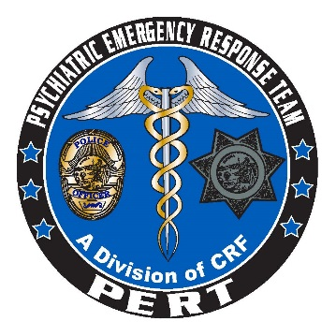

CRISIS INTERVENTION TRAINING
PERT ACADEMY
POST Approved: Course Number 2400-20801-17
Post Plan IV
STC Approved: Course Number 0071-068928
FY 2017-2018

This 24-hour course, sponsored by San Diego Police Department and San Diego County Health and Human Services Agency through the Psychiatric Emergency Response Team (PERT), will provide peace officers and dispatchers with the skills and knowledge to recognize individuals with mental illness, identify potential disorders, and de-escalate contacts with individuals in crisis. Training focuses on developing techniques for approaching persons who are living with mental illness (including individuals with developmental disabilities) and covers topics including communication skills, verbal de-escalation skills, suicide risk factors, suicide-by-cop, cultural issues, mental health legal issues, substance abuse, case study presentations, a consumer panel and a community resource fair.

Dates: September 19-21, 2017, November 14-16, 2017, January 16-18, 2018, March 6-8, 2018 and June 12-14, 2018
Hours: 0800-1700
Location: 1936 Quivira Way, San Diego, CA 92109- Marina Village Conference Center, Captain Room
Tuition: No Charge
Prerequisite: Current employment as a California peace officer or dispatcher
Attire: Business casual
Registration: All departments please email the PERT training coordinator at Ken.Smith@comresearch.org. Please submit your name, title/rank, dept/division, POST ID number, and a phone number. Spots fill quickly, please register early to guarantee your spot.

