
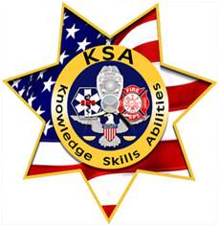
San Diego LE: $50 off regular price of $495
FYI!
Registration closes Monday, 10/17/16
Promotional Preparation: Assessment Center
Training Course – San Diego
All Ranks - Sworn & Non-Sworn
Two-Day Course, Oct. 22-23, 0830-1700 S/S
$445
Includes all the most common scenarios in assessment centers
Subordinate Counseling, Presentations, Meeting Management, In-Baskets
Also includes Structured Interviews

If you have to participate in an Assessment Center, this may be your only opportunity to get some “hands- on” experience before your test date.

Got an Assessment Center in your future? Here’s how you can learn to:

- Understand the assessment center rating and ranking system with feedback on your performance!
- Link the job dimensions of the new job from your previous related transferable experience(s) in any exercise
- Conduct a successful subordinate
counseling session or a citizen’s meeting
- Master the In-Basket: Practice working through an “In-basket” and learn what skills can be measured in this exercise.
- Write and present at command briefings, city council/board meetings, training, unit briefings, media events, or community meetings (with minimal prep time)
- Facilitate group discussions and enhance your Meeting management skills while achieving the objective(s) (Leaderless Group)
- Learn and apply effective: delegation techniques; project management, team building, and conflict resolution skills

- Demonstrate your transferable skills and personal values and ethics during oral or panel interview, assessment center or any performance based scenarios
- Coach and mentor everyone from the marginal performer to the seasoned veteran
- Develop a succession plan for your subordinates

Register Today as Space is Limited to 10 only!
See our web site for testimonials and to register!
http://assessmentcentertraining.org
Click on “Classes” tab to register
Or
Mail check or money order to: KSA Ltd., P.O. Box 504078, San Diego, CA 92150

Rick Michelson, Director KSA Ltd.
888-732-2173
assessmentcenterinfo@gmail.com

