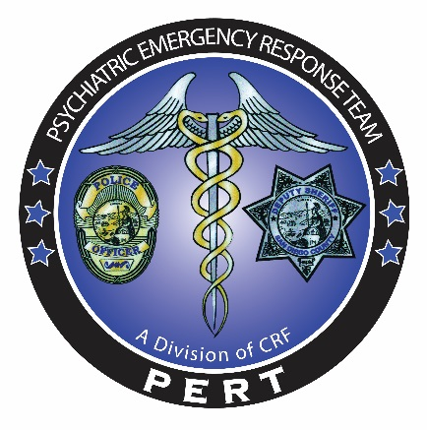

PERT CRT
Crisis Response Training
10 Hour Course
Fully interactive training encompassing mental health crisis
de-escalation and law enforcement responses
Dates: 2/26, 3/28, 4/21, 5/24, 6/9
0700-1700 Hrs
Open to all Law Enforcement Agencies

Presented by:
Mark Marvin, Ph.D., Director PERT
Marla Kingkade, Law Enforcement Liaison PERT
Designed for Law Enforcement Officers

0700 | 0800 | Overview of PERT/LPS/5150.05 | Dr. Marvin/M. Kingkade
0800 | 0900 | Recognizing Signs of Mental Illness | Dr. Marvin
0900 | 1000 | Auditory Hallucinations Listening Activity & Classroom Scenario | Dr. Marvin
1000 | 1100 | Communication and De-escalation | Dr. Marvin
1100 | 1200 | LUNCH
1200 | 1600 | FOS Exercises & 5150 Scenarios;  Two groups rotate | LE Training Officers/Dr. Marvin/PERT Team Leaders
1600 | 1700 | Debrief | PERT Staff

Registration: Please email the PERT training coordinator at Ken.Smith@comresearch.org. Please submit your name, title/rank, dept/division, POST ID number, and a phone number. Spots fill quickly, please register early to guarantee your spot.
Courses are pending POST approval and are held at La Mesa PD, 8085 University Avenue, La Mesa CA 91942
STC Cert No. 0017-083597

