San Diego Community College Police Department
Presents
Bulletproof Spirit
Emotional Survival Training to Protect and Heal the Spirit of Those who Serve
Thursday August 27, 2015 (0800 – 1200 hours)
San Diego City College – MS Building Room: MS140
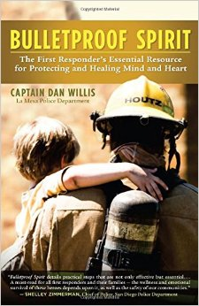
NO COST FOR THIS CLASS
- Suicide is the #1 Cause of Death for officers

- 120,000 officers have symptoms of PTSD

- 20% of officers have at least one addiction

- 25% of officers have stressed-based health issues


- 40% of officers have serious sleep problems

Without emotional survival training, officers are vulnerable to becoming seriously victimized by the job

TRAINING INCLUDES:

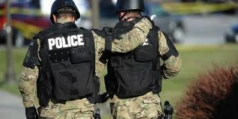
- Warning signs
- Emotional Survival Lessons
- 30 Emotional Survival and Wellness Strategies
- PTSD: Symptoms, Treatments: How to Prepare
- Critical Support from Home
- Peer Support/ Critical Incident Stress Management
- Methods to process stress, overcome trauma, serve with compassion without being crippled by the job

Instructor: La Mesa Police Captain (ret) Dan Willis served 26 years and is a graduate of the FBI National Academy. He is a former crimes of violence, child molest, homicide detective and SWAT Commander. He’s taught at the SD Police Academy for 10 years and is the author of “Bulletproof Spirit: The First Responders Essential Resource for Protecting and Healing Mind and heart.”

To reserve a slot for this class: https://www.eventbrite.com/e/bulletproof-spirit-tickets-17082363810

Information to schedule training or purchase book: Firstresponderwellness.com

