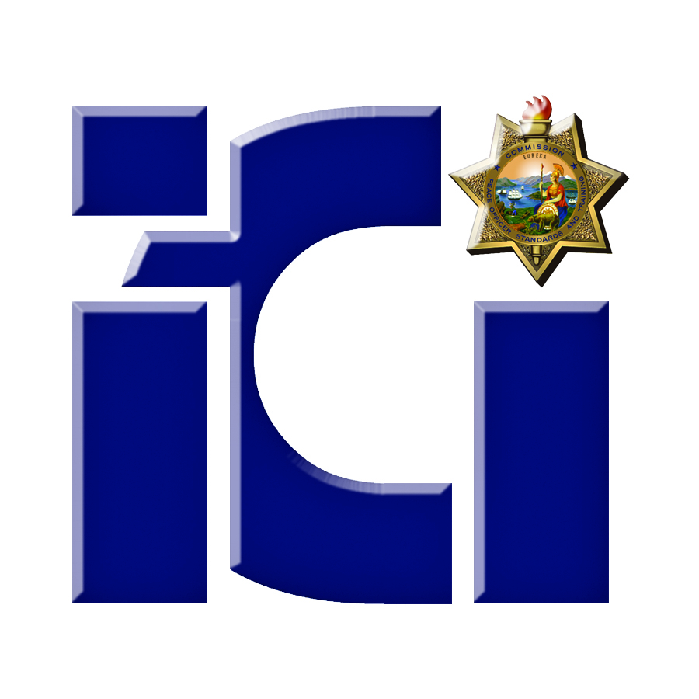
P.O.S.T.
ICI Officer-Involved Shooting and Force Investigations Course

February 24-28, 2014
8:00 am – 5:00 pm
Course Description

Designed for experienced detectives, this 40 - hour scenario based training will focus on critical incidents, including: officer-involved shootings; use of force incidents; and in- custody deaths. Participants will be assigned to an investigative team, respond to a different use of force incident scene, and conduct an investigation into the scenario incident. Investigation techniques will include crime scene management and documentation, conducting interviews, and evidence collection. A participant presentation to a panel of experts will culminate this training.

Prerequisite: Minimum of one year investigative experience or current assignment as an investigator or investigative unit supervisor/manager; and successful completion of a minimum of 80 hours of general or specialized investigator training.

Registration Information

This course is presented by San Diego Miramar College
To register for this training contact: Jim Collins, Course Coordinator
Phone: (619) 990-5216
Email: jccollin@sdccd.edu
POST Plan IV (tuition free, travel/per diem reimbursement) is used for the Core Course and most foundation specialty courses to those agencies eligible for POST reimbursement.

Location: Day 1 & 2 - San Diego Public Safety Training Institute
4347 N. Harbor Dr. , San Diego, CA 92101
(Just west of San Diego International Airport)

Lodging: Courtyard by Marriott Mission Valley
595 Hotel Circle South, San Diego, CA 92108
(619) 481-5889



