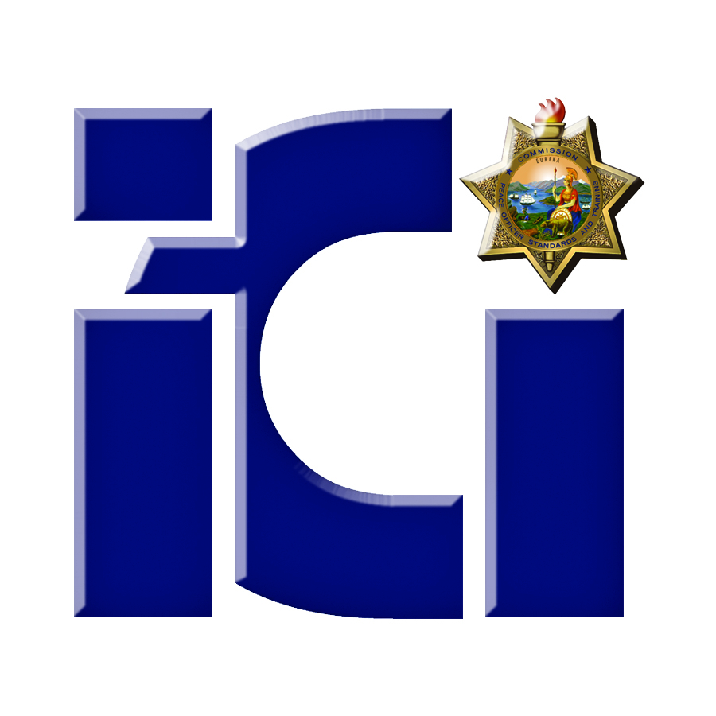
P.O.S.T.
ICI Officer-Involved Shooting and Force Investigations Course

Course Description

Designed for experienced detectives, this 40 - hour scenario based training will focus on critical incidents, including: officer-involved shootings; use of force incidents; and in- custody deaths. Participants will be assigned to an investigative team, respond to a different use of force incident scene, and conduct an investigation into the scenario incident. Investigation techniques will include crime scene management and documentation, conducting interviews, and evidence collection. A participant presentation to a panel of experts will culminate this training.

Prerequisite: Minimum of one year investigative experience or current assignment as an investigator or investigative unit supervisor/manager; and successful completion of a minimum of 80 hours of general or specialized investigator training.

Registration Information

This course is presented by San Diego Miramar College
To register for this training contact: Jim Collins, Course Coordinator
Phone: (619) 990-5216
Email: jccollin@sdccd.edu
POST Plan IV (tuition free, travel/per diem reimbursement) is used for the Core Course and most foundation specialty courses to those agencies eligible for POST reimbursement.

Course Dates:

November 18 - 22, 2013
February 3 - 7, 2014
February 24 - 28, 2014
April 28 - May 2, 2014
June 2 - 6, 2014



