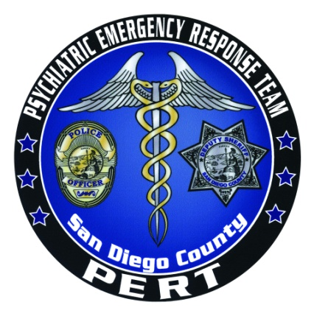

CRISIS INTERVENTION TRAINING
PERT ACADEMY
POST Approved: Course Number 2400-20801
Post Plan IV
STC Approved: Course Number 0071-068928
FY 2013-2014

This 24-hour course, sponsored by San Diego Police Department and San Diego County Health and Human Services Agency through the Psychiatric Emergency Response Team (PERT), will provide peace officers and dispatchers with the skills and knowledge to recognize individuals with mental illness, identify potential disorders, and de-escalate contacts with individuals in crisis. Training focuses on developing techniques for approaching persons who are living with mental illness (including individuals with developmental disabilities)and covers topics including communication skills, verbal de-escalation skills, suicide risk factors, suicide-by-cop, cultural issues, mental health legal issues, substance abuse, case study presentations, a consumer panel and a community resource fair.

Dates: October 15-17, 2013, January 14-16, 2014, April 15-17, 2014 and June 17-19, 2014
Hours: 0800-1700
Location: 1936 Quivira Road, San Diego, CA 92109- Marina Village Conference Center, Bay View Room
Tuition: No Charge
Prerequisite: Current employment as a California peace officer or dispatcher
Attire: Business casual
Registration: All departments please contact the PERT administrative office at 619-276-8112. Please have your POST ID number available when you call to register. Spots fill quickly, please call early to guarantee your spot.

