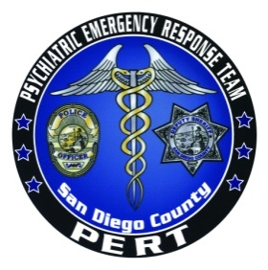

PERT Academy
Introduction to Mental Health/PERT
8 Hour Course
FY 2013-2014
Dates: 9/17/13, 11/7/13, 3/18/14, 5/22/14
0800-1700
POST Approved: Course Number 2400-20906
STC Approved: 0071-0688641
Open to all Law Enforcement Agencies

Presented by:
Dr. Jim Fix, Psy.D. Executive Director PERT
Marla Kingkade, Law Enforcement Liaison PERT
Dr. Myrna Rasmussen, Ph.D., Consultant to PERT

Designed for Law Enforcement Officers and Dispatchers

0800 | 0830 | Registration and opening remarks | Fix and Guests
0830 | 0930 | Intro to PERT and Officer Safety | Kingkade and Guest
0930 | 1130 | Intro to Mental Illness and Major Mental Disorders | Fix and Rasmussen
1130 | 1230 | NAMI Panel | Fix and Guests
1230 | 1330 | Lunch on-site with NAMI Panel | Fix and NAMI Panel
1330 | 1430 | Suicide Assessment and Intervention | Fix and Rasmussen
1430 | 1530 | Communication and De-Escalation Techniques | Fix and Rasmussen
1530 | 1630 | Community Resources and LPS Facilities | Fix
1630 | 1700 | Post Test, Wrap-up, Evaluations, Certificates | Fix

Registration: Please contact the PERT administrative office at 619-276-8112. Please have your POST ID number available when you call to register. Please call PERT directly to reserve your spot. Classes fill quickly, please reserve your place ASAP.
All the above courses are held at Marina Village, 1936 Quivira Way, San Diego, CA 92109

