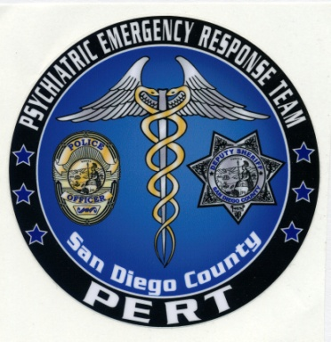

CRISIS INTERVENTION TRAINING
PERT ACADEMY
POST COURSE NUMBER 2400-20801
Post Plan IV

This 24-hour course, sponsored by San Diego Police Department and San Diego County Health and Human Services Agency through the Psychiatric Emergency Response Team (PERT), will provide peace officers and dispatchers with the skills and knowledge to recognize individuals with mental illness, identify potential disorders, and de-escalate contacts with individuals in crisis. Training focuses on developing techniques for approaching persons who are living with mental illness (including individuals with developmental disabilities)and covers topics including communication skills, verbal de-escalation skills, suicide risk factors, suicide-by-cop, cultural issues, mental health legal issues, substance abuse, case study presentations, a consumer panel and a community resource fair.

Dates: Jan 15-17, April 16-18, June 18-20, October 15-17 2013
Hours: 0800-1700
Location: 1936 Quivira Road, San Diego, CA 92109- Marina Village Conference Center, Bay View Room
Tuition: No Charge
Prerequisite: Current employment as a California peace officer or dispatcher
Attire: Business casual
Registration: SDPD contact Gloria Schick at your training department 619-388-7955; all other departments contact the PERT administrative office at 619-276-8112. Please have your POST ID number available when you call to register.

